- Kalypso PTC Team -

Steps for creating PTC Partner Account

**1.** **Create Basic PTC.com Web Account**:

<http://www.ptc.com/appserver/common/account/basic.jsp>

1. Required information:

* Your name and
* Your company email address. Email addresses are used for usernames.

1. If you have an existing “Basic” account proceed to step (2) and upgrade your account to a PTC Partner account.
2. If you have an account but forgot your password, you can have your [password reset](http://www.ptc.com/appserver/common/account/password.jsp)
3. If you have a basic account you can [change your password](http://www.ptc.com/appserver/common/account/secure/wamPersonal.jsp).

Example: Basic Account Creation:

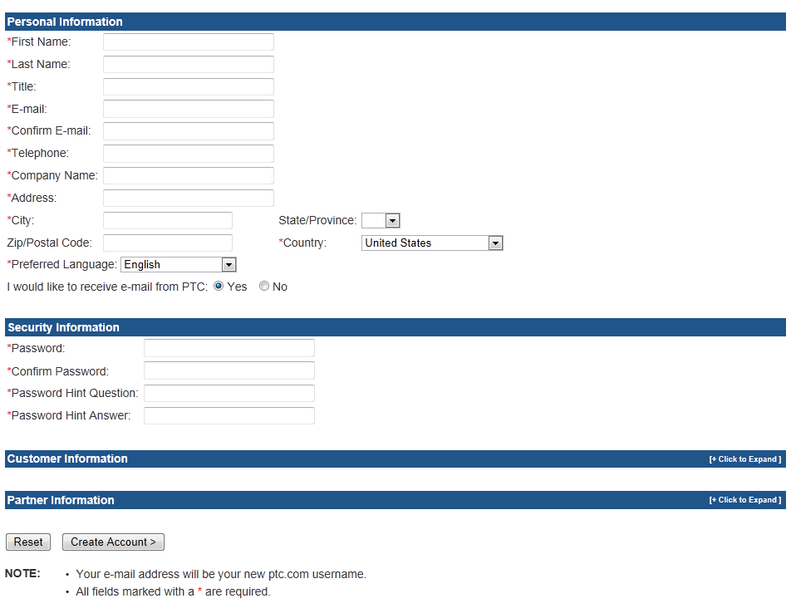

**2.** **Upgrade Account for Partner Access:**

<http://www.ptc.com/appserver/common/account/secure/premiumAccount.jsp>

1. Required information:
   * Have a [Basic PTC Account](http://www.ptc.com/appserver/common/account/basic.jsp)
   * Customer Number for Kalypso = **423505**
   * Security ID for Kalypso = 001A000000TOpAuIAL
   * Sales Order Number (SON) for Kalypso = **2698059**

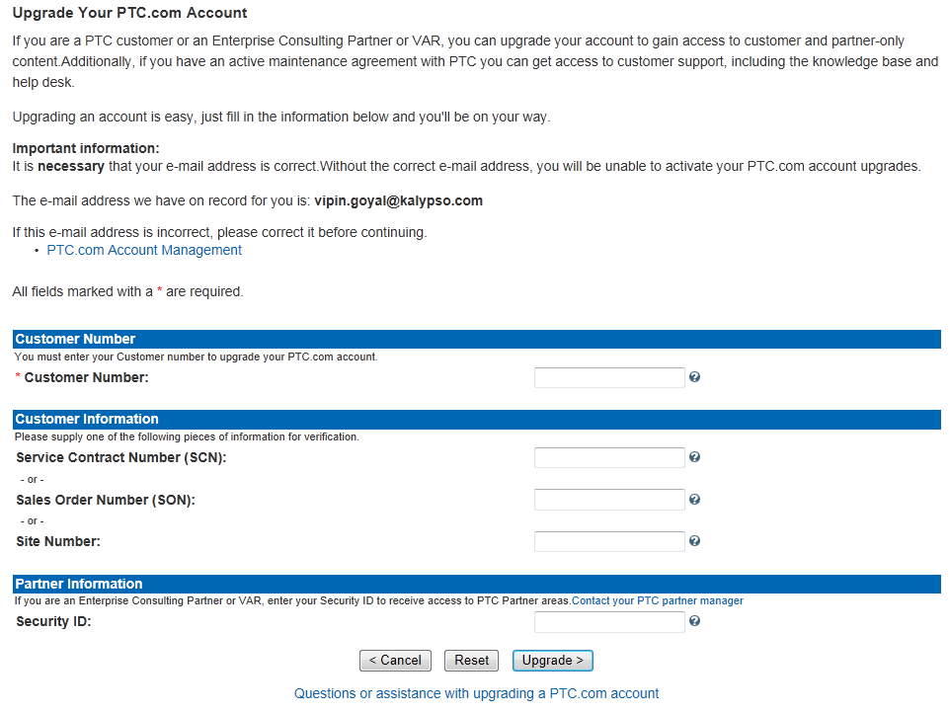

1. You will receive an email from PTC asking you to “Activate your PTC.com account upgrades”. Click on the link in the email that you receive to activate your upgrade.

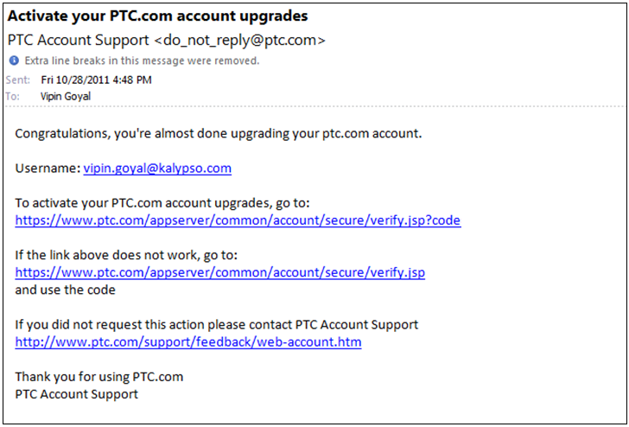

1. Notify PTC ([servicepartners@ptc.com](mailto:servicepartners@ptc.com)) To Whom It May Concern: I was instructed to notify you in order to complete my upgrade process. My name is ___ and I work for Kalypso.
2. Once the upgrade is complete, it takes as long as four hours to replicate through the system. You are asked to **NOT** log into PTCU during that window, as doing so will cause the replication to fail.
3. Once the replication is complete (roughly four hours), the individual should be able to access PTCU and the Partner Portal
4. If you have any questions about your privileges to access a PTC Partner Web Application, you can contact one of these individuals:
   * For Windchill: Van Gresham and Jason Schrader
   * For FlexPLM: Vipin Goyal

**3. PTC University:** Once partners upgrade their account to have Partner privileges and Customer Supportprivileges (~24 hours) Partners will automatically have access to [PTC University](http://www.ptc.com/Saba/Web/ptcu)